Figma Demo Guide
Task:
Use a template and reusable components to design an AI chatbot UI in E-Commerce App.

Workflow:
- Enter the template interface
Open the template by clicking the link first
https://www.figma.com/design/Zmo9iaflL22YWGhn4DYz96/AI-Chatbot-Design?node-id=304-463&t=Ucjqutnd2I3OKEkm-1

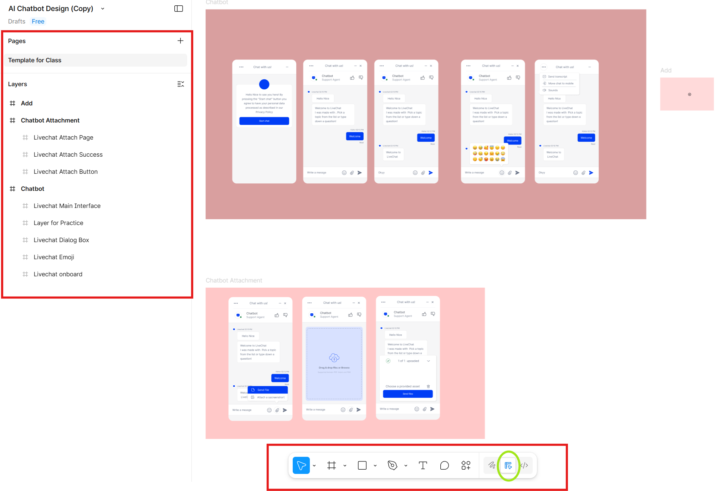
The Template interface is shown above. There are two parts labeled with red line you should pay attention to.
The left panel is the navigation panel. It includes key sections:
- Pages list → Switch between or add new pages in your file (you see "Template for Class")
- Layers panel → Shows the full hierarchy of everything on your current canvas (frames, groups, rectangles, text components like "Chatbot Attachment", "Livechat Attach Button", etc.)
- Assets tab → Displays components, libraries, and reusable elements in your file

In the bottom part, that is the Main Tools Bar. This is where you access the core creation and editing tools to draw, select, and modify elements directly on the canvas, such as move tools, shape tools, pen tools, etc.

Besides tools, the bar shows 3 different modes --- draw mode, design mode and the dev mode ( we don’t consider this time). The green circle shows you are in the design mode.

The draw mode is a focused workspace for illustration and visual expression while the design mode is the traditional space for UI/UX design, component-based work, and prototyping.

- Duplicate the template to your draft
After getting the basic understanding of figma, let us take a practice. But first we should duplicate a copy to your own draft so that you can edit in you own way. Click the file menu and choose the “Duplicate to your drafts”. Then you can see the copy version in your draft.
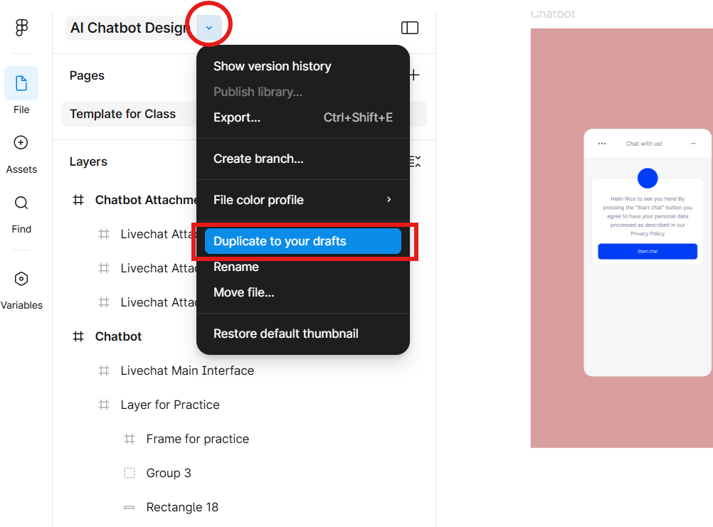
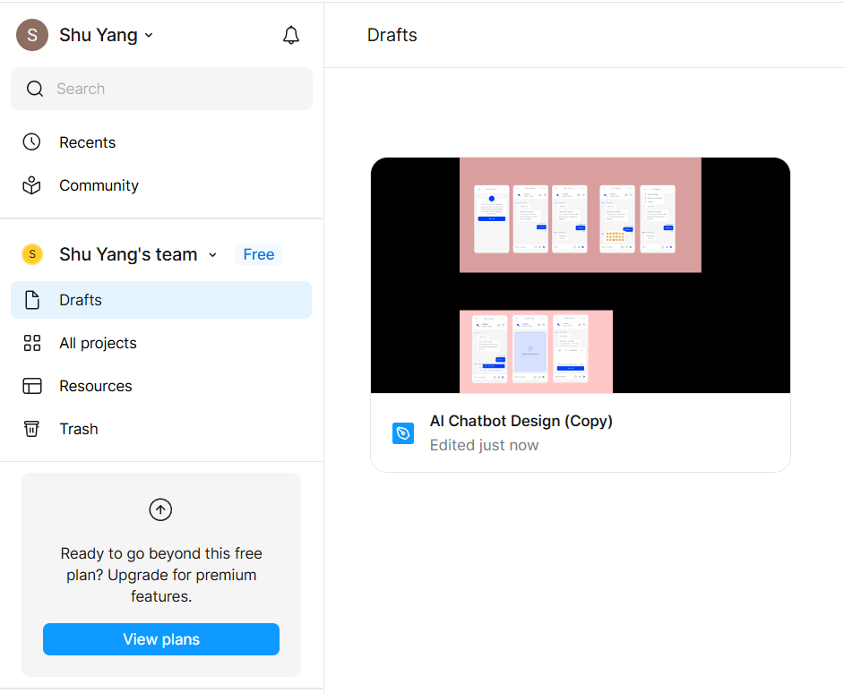
- Try to use the provided assets and insert them in the page
Firstly, click the Assets in the left panel and choose the “iOS and iPad OS 26 UI Kit” library which is embedded in Figma.
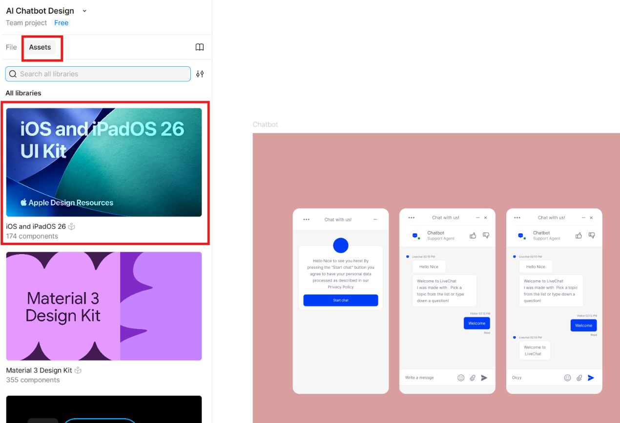

Secondly, choose one instance you like in the library and click the insert instance and move it into the “ livechat Attach Success ” sublayer , under the “Frame for trying”. (Directly drag this component to the location you like )
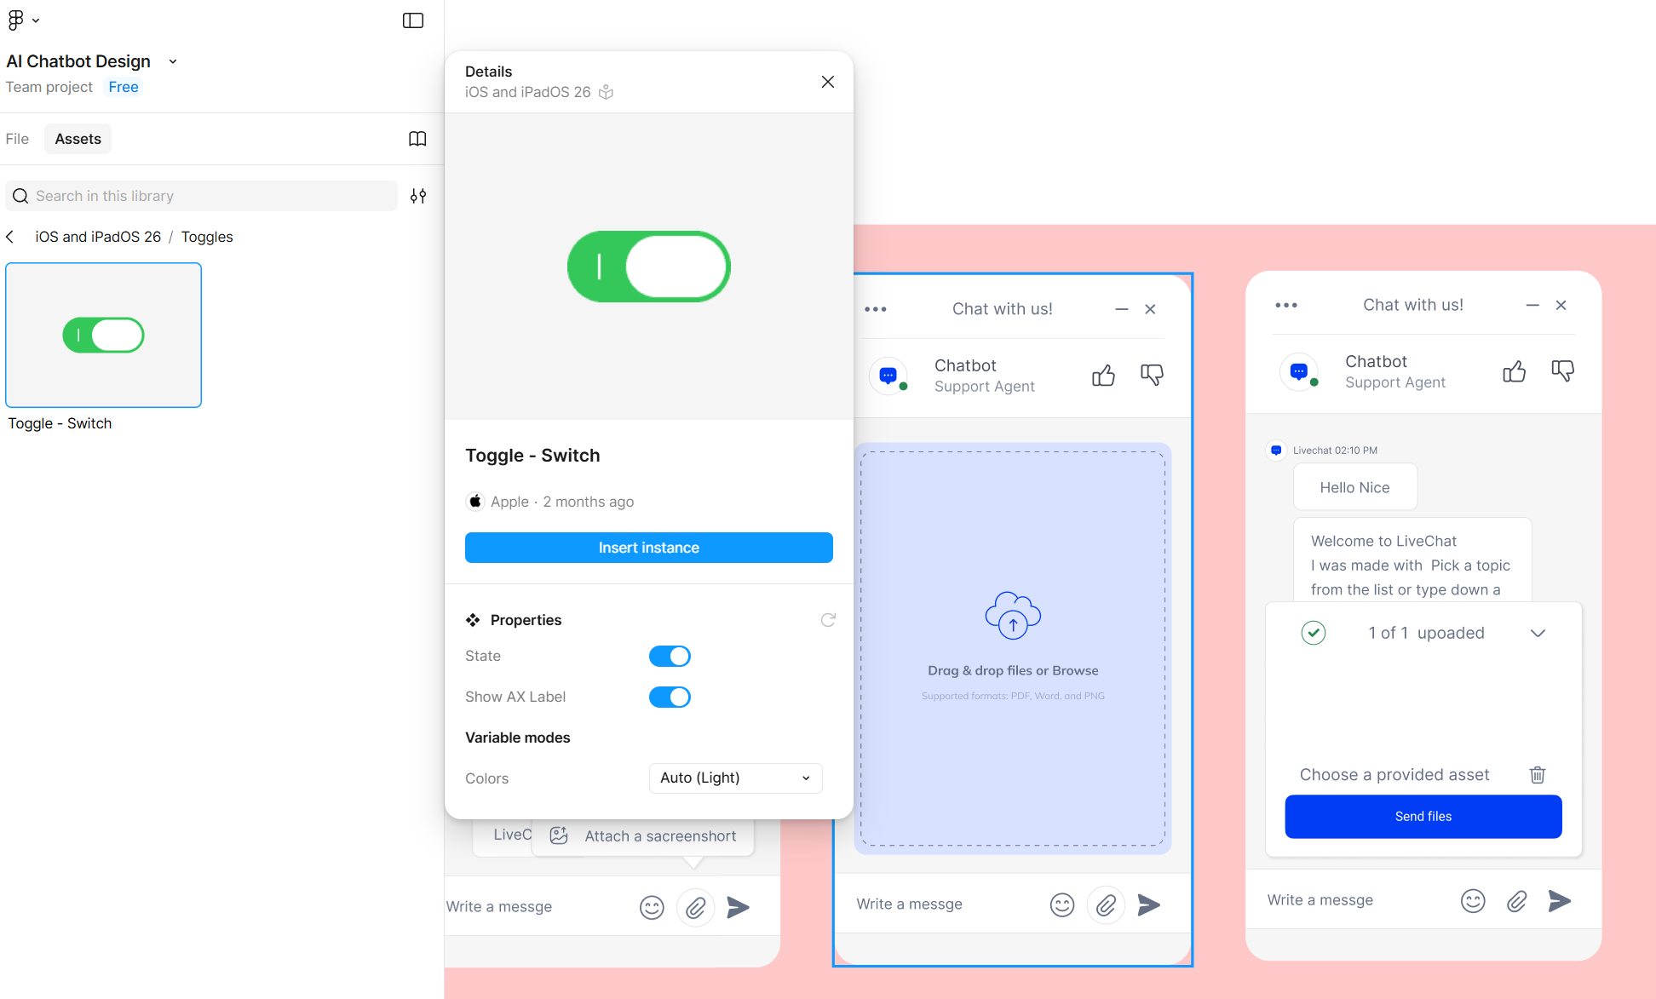

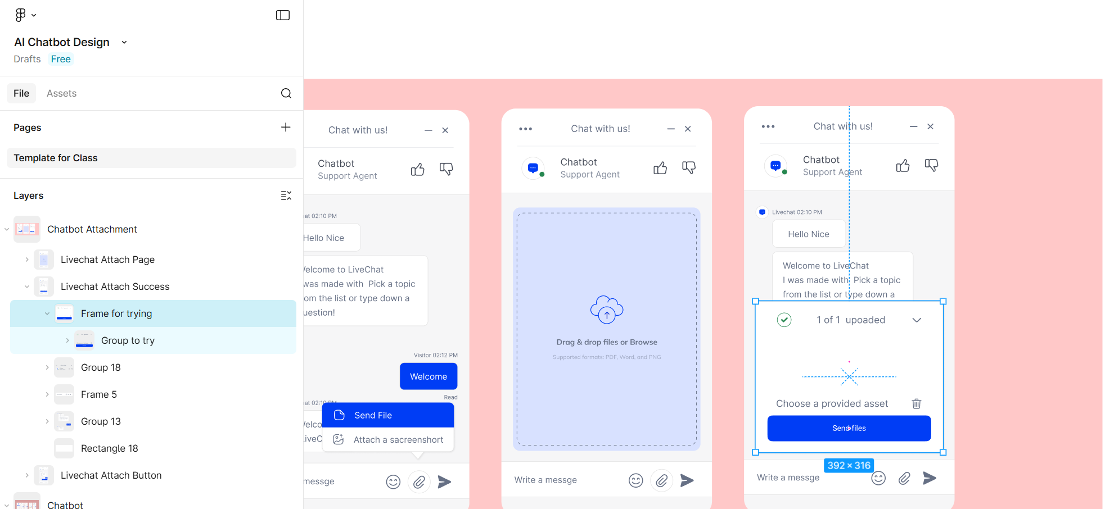
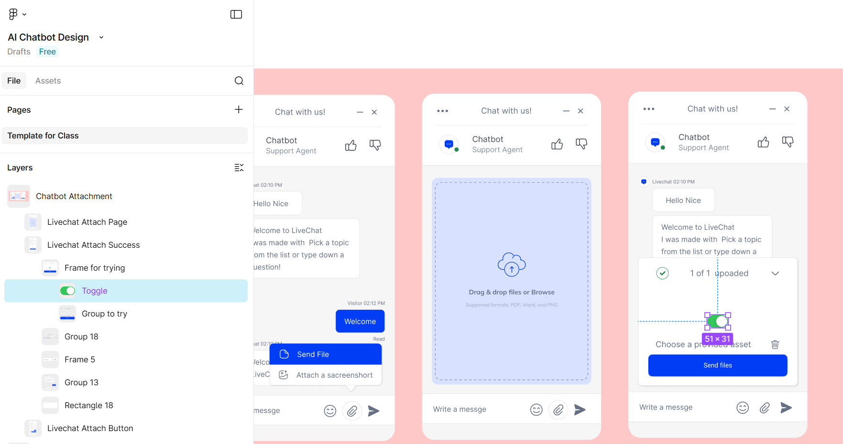

- Let's try modifying a frame
Locate the “Frame for practice ” and take the following actions:
- Delete the “Group - - remove”
- Change the “Sounds” into “Volume” in the “Group –text”
(Reminder: directly edit the text frame in the page by double clicking. Edit the left panel doesn’t change the text value since it only changes the name of this text component)
- Replace the “Group - - replace” by using the same icon as the one in the “Add” layer button, and change the text to “Add a new chat”.
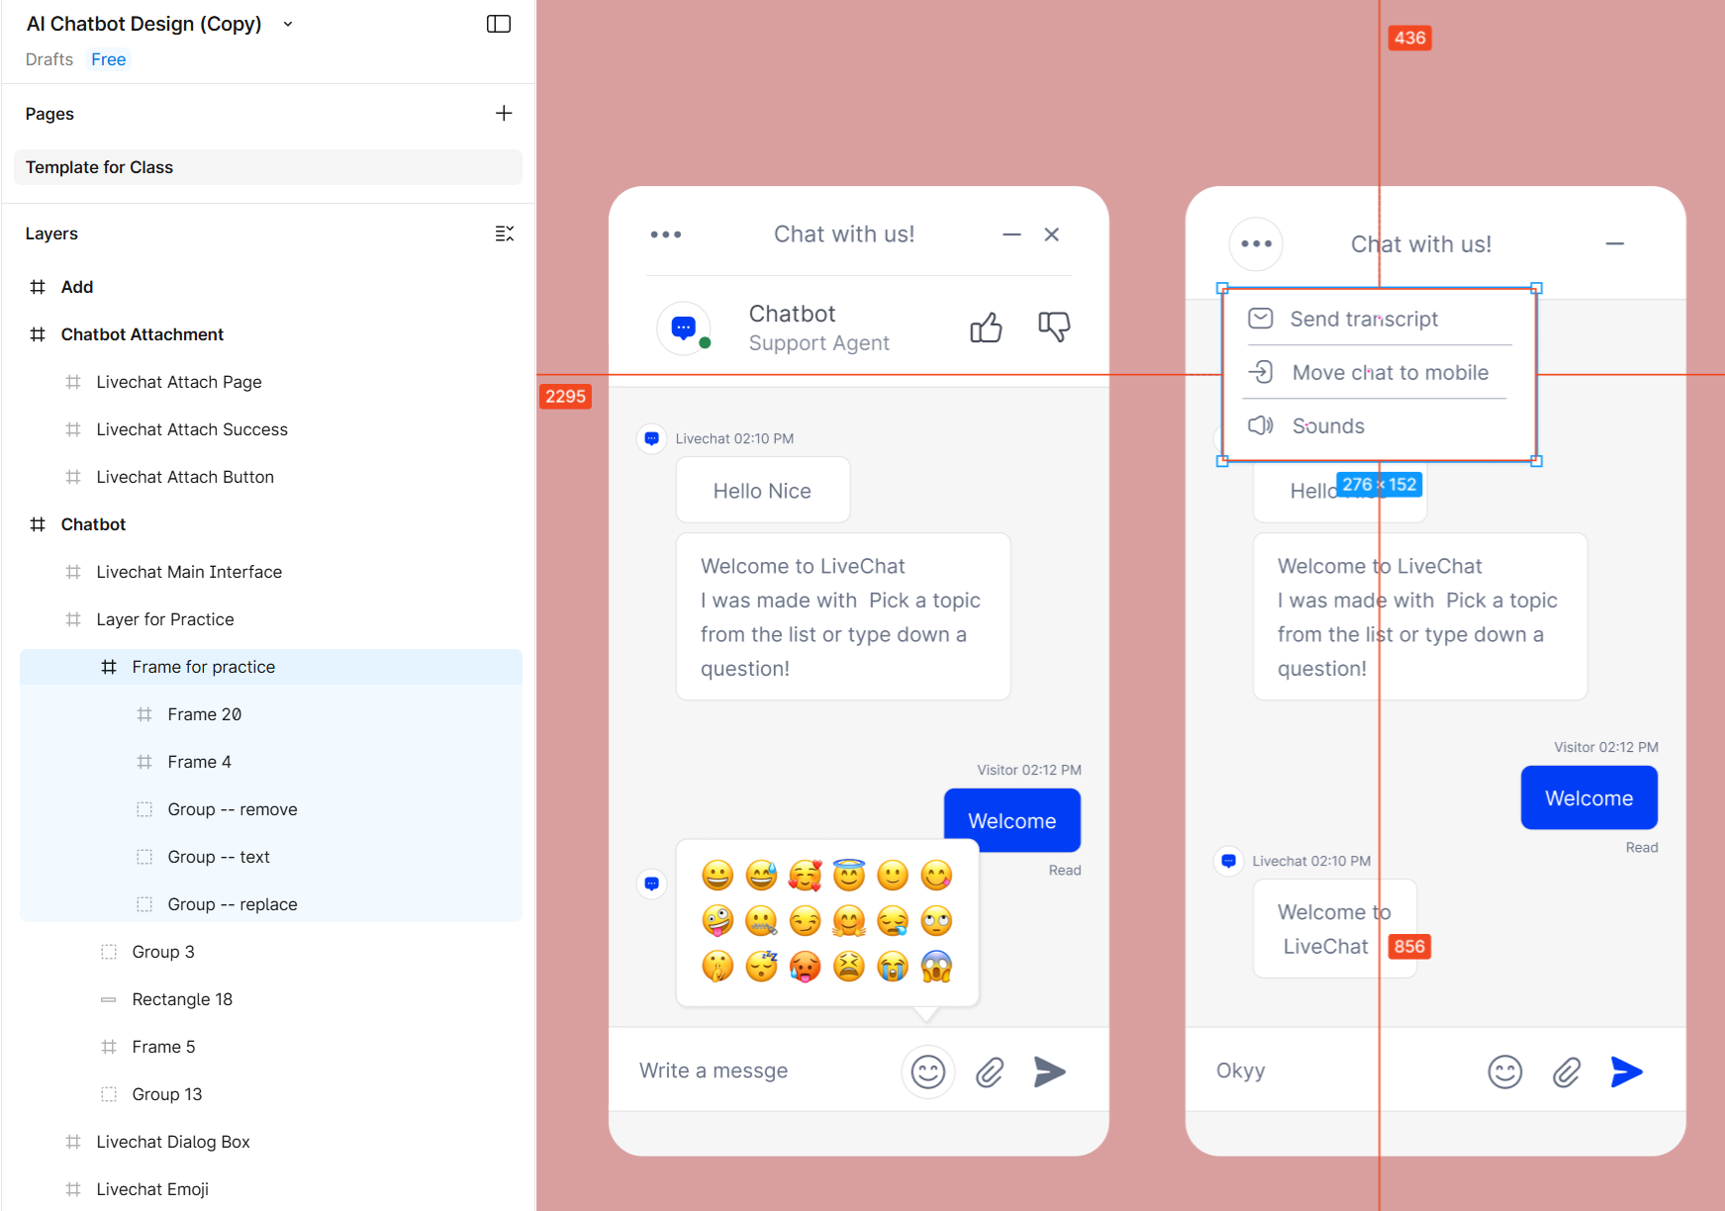
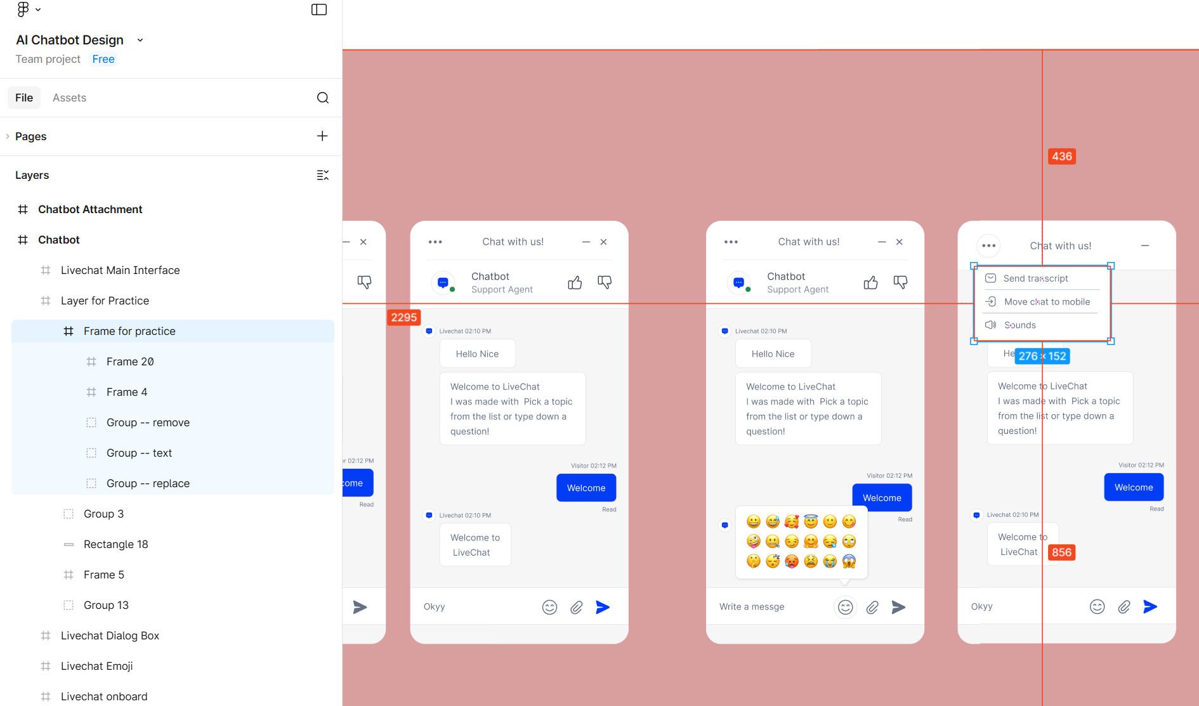

- Use the Figma Make function in design mode and turn the static page into interactive page
After trying the reusable assets and modifying the design, let us make the page alive. Firstly, select the layer you want to upload (Max number: 3). You can press Ctrl to multi-select. Then right click and choose “Send to Figma Make”. It will automatically jump to the prompt page where you can send the request to Figma Make.

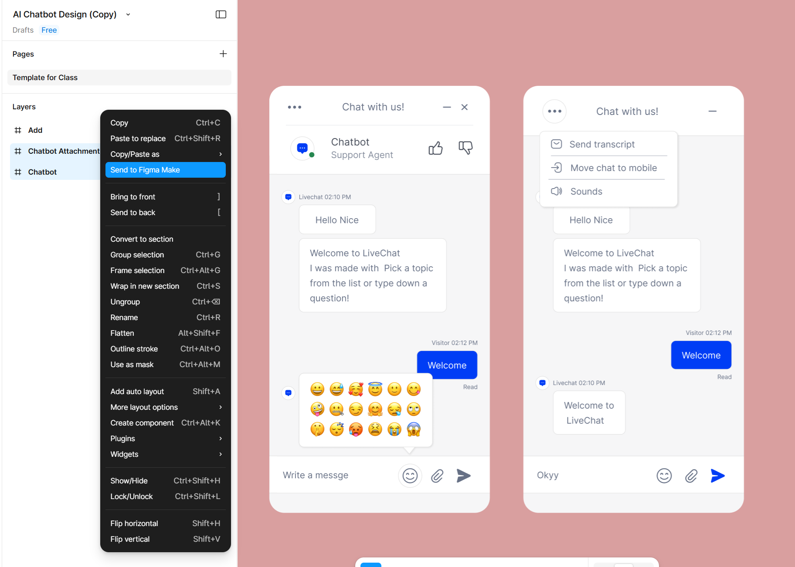
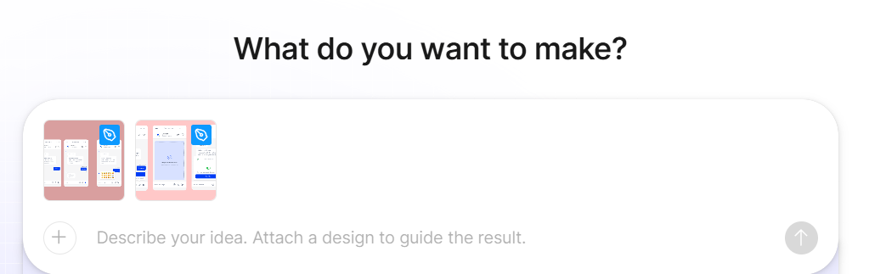

- Prompt and make continuous improvement
Try to send your requirement to the figma and see if there is any improvement you find. If so, ask the figma to change until you are satisfied.
